Dear Partners and Prospective Partners:
Welcome to Louisiana DECA!
DECA is a 501(c)(3) not-for-profit organization of more than 225,000 members worldwide, making it one of the largest and most successful student organizations in the world. DECA is an academic and professional association of high school and college students with an interest in careers within the fields of business, marketing, finance, hospitality/tourism, culinary arts, fashion merchandising, retail and management. DECA’s purpose is to integrate skills into classroom instruction through authentic, experiential learning methods that prepare members for college and careers. DECA further provides for competitions and conferences that allow students to apply the knowledge gained through project-based activities and through connecting them with businesses so they may gain realistic insight into the industries in which they are interested.
As part of the international organization, the Louisiana DECA state association hosts 4 annual conferences for our over 1,000 high school and collegiate members throughout the state. Through various cases, pitches, series of tests and industry applicable challenges, these conferences shape our delegation into the present and future leaders of society and business.
By becoming a Louisiana DECA t-shirt sponsor for a minimum donation of $200, your business name or logo will be printed on all four (4) shirts worn by our students, staff and professional members throughout the school year:
The Louisiana DECA Fall Excellence Career Development Conference in October or November.
The Sports & Entertainment Marketing Conference with the New Orleans Pelicans in December or January.
The Louisiana DECA Career Development Conference in late February or early March.
The International Career Development Conferences in April.
With over 1,000 members throughout the state, this is a great opportunity to give back and promote your business while supporting a worthwhile cause. Many wear these shirts to chapter events locally and after the year has concluded.
For more information or questions, please contact Paul Grethel at paul.grethel@gmail.com. We can spell out your company or you can send us your logo design. Logos should be sent in high-resolution via email or shared to this email address.
We thank you for your consideration and hope to add your name to our list of business partners this year!
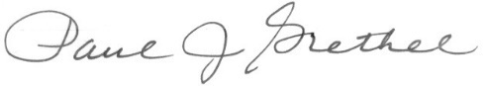
Sincerely,

Louisiana High School DECA Executive Director

LOUISIANA DECA T-SHIRT SPONSORSHIP FORM

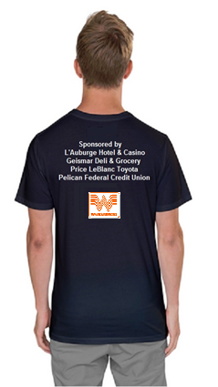
As part of the international organization, the Louisiana DECA state association hosts 3 annual conferences for our over 1,400 high school and collegiate members throughout the state and we attend 1 international conference. Through various cases, pitches, series of tests and industry applicable challenges, these conferences shape our delegation into the present and future leaders of society and business.

By becoming a Louisiana DECA t-shirt sponsor for a minimum donation of $200, your company name will be printed in our state conference program and on all four (4) shirts worn by our students, staff and professional members throughout the 2017-18 school year, including:
1. The Fall Competitive Excellence Conference in October (sponsorship form due by Sept. 27 to be included on this shirt and the 3 below)
2. The Sports & Entertainment Marketing Conference with the New Orleans Pelicans in December (sponsorship form due by Nov. 18 to be included on this shirt and the 2 below)
3. The Louisiana DECA Career Development Conference in Feb./March (sponsorship form due by Feb. 1 to be included on this shirts and conference below)
4. The International Career Development Conferences in April (sponsorship form due by March 22 to be included on this shirt)

With over 1,000 members throughout the state, this is a great opportunity to give back and promote your business while supporting a worthwhile cause. Many wear these shirts to chapter events locally and after the year has concluded.

Logos (if provided) should be emailed to the address below. Fill out this form. If you have any questions, please contact Paul Grethel 504-301-7194 or email him at paul.grethel@gmail.com.

The sooner you get your sponsorship form in, the more shirts your business name will appear on.
LOUISIANA DECA T-SHIRT SPONSORSHIP FORM
Student’s Name
(who gave you this form, if any)
Sponsor’s Name
(first and last name)
Sponsor’s Phone
(Including area code)
Sponsor’s Email Address
Sponsor’s Business Name to Appear on Back of T-shirts (If a business logo is emailed in, we can put that on the back of the shirt as well.)
Return this form with a check for $200 payable to Louisiana DECA, 26236 Wax Rd., Denham Springs, LA 70726.
DECA is a 501(c)(3) not-for-profit organization of more than 220,000 members worldwide, making it one of the largest and most successful student organizations in the world. DECA is an academic and professional association of high school and college students with an interest in careers within the fields of business, marketing, finance, hospitality/tourism, culinary arts, fashion merchandising, retail and management.

