Louisiana DECA

State Officer Candidate’s Application Forms

Applications must be postmarked by February 15.
Download the entire application at www.louisianadeca.com/officers

Please mail applications to: Louisiana DECA

26236 Wax Rd.

Denham Springs, LA 70726

We are happy that you wish to run for a DECA state officer position. With this comes great responsibility. You must agree to make DECA your number one priority. In response to your efforts, La. DECA will be making a large investment in your growth during the year.

Please include the following to apply for a La. DECA office:

1. Louisiana DECA Officer Application
- Louisiana DECA Officer Code of Conduct
- Officer Dressing Measurements form
- Louisiana DECA Officer Travel/Medical Release
- Louisiana DECA Officer Candidate Advisor’s Responsibility & Principal‘s Authorization Form
- Two letters of recommendations (one from advisor/one from someone else who must identify their relationship with you; do not use friends; person must be an adult)
- Verification of at least a 2.0 Scholastic GPA from school counselor/school official (a letter or transcript showing GPA)

Voting delegates decide on the 5 final officers who will fill the positions listed below, but they do not vote on their positions. The exact positions are determined by the La. Board of Directors. On your application, please list the position or positions for which you are interested. The duties of the high school officers shall be as follows:
President: to call to order and preside at all meetings and perform any other duties assigned to him by the Constitution, By-Laws, or Delegates. The President will practice the “Entrepreneurial” and “Management” elements of DECA’s Mission Statement and is responsible for connecting with Chartered Association Officers and establishing chapter vision, management, and organization that ensures each chapter officer has the training, support, accountability, and resources to deliver a powerful DECA experience for each DECA member.
Vice-President of Leadership: to be responsible for all non-competitive event career and leadership activities such as DECA Campaigns, Community Service, Recognition & Scholarships, and Leadership Training.
Vice-President of Marketing and Communications: to be responsible for initial member recruitment, branding, promotions, correspondence and social media.
Vice-President of Finance & Career Development: to be responsible for budgeting, accounting, fund development efforts as well as programs to allow members to explore different career paths
Vice-President of Hospitality: to be responsible for connecting members and guests to a welcome, value-filled, fun educational experience.

The candidate will also be responsible for a 1-3-minute video-taped speech discussing his/her platform. This speech will be shown during opening session and should be presented in a professional manner. Candidates should wear business attire in their video. Upload the video to the Dropbox folder; if you need an invite to the folder email paul.grethel@gmail.com. Campaign rules are as follows:
  - Between February 1 and the CDC, you can do one mail-out to chapters of a letter, flyer, or brochure, prior to the conference if you would like to. Contact the state advisor for a list of DECA Chapters and addresses.
  - All candidates must have a campaign booth/table; La. DECA will provide a table for each candidate. Booths can be set up between 10 a.m.-1:30 p.m. on the first day of the conference and must be taken completely down by 11:30 p.m. on the first day of the conference.
  - Candidates can have no more than two (2) non-paper handouts (i.e. buttons, pens, novelty items, candy, etc.). Stickers are not allowed; do not tape or glue anything to hotel property. Flyers and posters are allowed; however, NOTHING can be posted to hotel property; easels or display boards may be used for this. One brochure, one type of business card, one flyer, and/or other paper materials can be used (you can have all these, but only one set of each kind).
  - Picket-type campaign signs are allowed, but they should not be in the air during general sessions; disruptions will not be tolerated. Cheers, songs, etc. will only be allowed during times when campaigning is taking place, such as when the candidate is being announced to give his/her speech.
  - To decorate the candidate’s campaign table, you can use things such as tablecloths, lights, balloons or flyers to attract attention. Do not use anything loud that could be disruptive to other activities. If you do need electricity, you must bring an extension cord and find an outlet. Select your table upon arrival.
  - Disruptions, use of inappropriate items, posting of materials on hotel property or breaking any of the above rules are grounds for disqualification.
  - Candidates need to video their speech and email it to the state advisor or upload the video of themselves to the DECA Dropbox. Ask your advisor to request an invite to the Dropbox folder so you can upload it by February 28. This will be shown at the Opening Session.
  - On Monday, all candidates will attend the voting delegate meeting to answer questions by the delegates before they vote. Once is it time to vote, the candidates must stay at least 50 feet from voting delegate room until the election is over. There must be no active campaigning after lunch time on Monday. You will then go to your state officer interview. Look in program for room #. Be aware of the following interview criteria.

Interview Structure and Screening Criteria – Nominating Committee
The Nominating Committee is comprised of 3-5 members. They will ask candidates questions related to character, DECA, and leadership. Candidates are screened on the following criteria, 100 points total. These interviews are held during the CDC.
Pre-Interview Introduction (10 points)
Introduced self properly Physically poised and ready Spoke clearly, forcefully
State the office sought Stood until invited to sit Good first impression
Character Question Response (15 points)
Candidate’s answers show a strong sense of character, genuineness, and honesty. Answers suggest candidate will work well with fellow DECA members and model good citizenship. Answers are organized, logical, and reasonable. Candidate maintains composure, uses precise words, is interesting to listen to and thinks questions through.

DECA Question Response (15 points)
Candidate’s answers show a strong understanding of La. DECA. Ideas and plans for the future of La. DECA are strong and reasonable. Answers show candidate has a strong sincerity in the organization. Candidate maintains composure, uses precise words, is interesting to listen to and thinks questions through.
Leadership Question Response (20 points)
Candidate’s answers show understanding of traits of a good leader. Answers suggest candidate has self-initiative, dedication, and the ability to motivate many people to accomplish a common goal. Candidate maintains composure, uses precise words, is interesting to listen to and thinks questions through.
Appearance (10 points)
Good color coordination Hair clean and neat Good posture
Clothing clean and pressed Wore professional attire Pleasant smile
Facial hair (if any) is natural
Attitude (10 points)
Attentive Alert and responsive Self-confident
Enthusiastic Competitive and open minded Sincere and conscientious
Socially at ease and comfortable
Professionalism (10 points)
Courteousness Ability to remember names Ability to take criticism
Poise Sense of humor Conversational
Post-Interview (10 points)
Thanked the committee Left promptly and still eager Remained poise

Louisiana DECA

Officer Candidate Application

TYPE THIS APPLICATION

Please type the information in the space below. You may use another page if necessary:
Officer Position(s)  Rate these 1-5 in the order of your preference with #1 being the office position to which you most aspire. |  | President
 |  | Vice-President of Leadership
 |  | Vice-President of Marketing & Communications
 |  | Vice-President of Finance & Career Development
 |  | Vice-President of Hospitality

Your Name (First, MI, Last)

Social Security #

(used for White House clearance in DC)

Are You a Citizen of the U.S. (Y or N)

What City Where You Born In?

Home Address

Home Phone # (area code)

Cell Phone # (area code)

(you must have one) E-mail Address

If you receive text messages, who is your cell phone service provider? (i.e. Verizon, AT&T, Alltel, etc.)

Your Facebook Name

Your Twitter Handle

Your Instagram Handle

School’s Name

School Address

School Phone # (area code)

Advisor’s Name

Advisor’s Phone # (area code)

Advisor’s E-mail Address

Year in School (9th, 10th, 11th, 12th)

Date of Birth

Type Parent(s) full names

Briefly describe your DECA
involvement on the local, state & national levels

Career Goal (50+ words)

Platform for La. DECA

(plans and goals for next year as a

state officer of La. DECA)

Louisiana DECA State Officer

Code of Conduct

I agree to follow the State DECA Officer Code of Conduct while I am representing the Louisiana Association of DECA as a member of the State Officer Team. I understand that violation of any of the following the Code of Conduct will result in either probation for the remainder of the school year or dismissal from office.

Violation of the Following will result in Probation for the Remainder of the Year:
- I will wear appropriate dress and have proper grooming at all official functions as determined by the state advisor. Denim and jean-like apparel are appropriate at certain dances, but not during any other official sessions or meeting. Even during “down” time, I understand that officers should dress in clothing that is tasteful. Stage dress must be pre-approved if I am not in uniform attire. Failure to wear appropriate attire will also result in not being on stage for a DECA function.
- I will follow the directives of the State Officer when attending DECA conferences realizing that the State Advisor is my advisor, and I will notify the DECA state advisor of all invitations for representation of DECA.
- I will refrain from dating fellow state DECA officers while I am in office. I understand that if my boyfriend/girlfriend attends a DECA function, I must refrain from the appearance of dating that person and work in the capacity of a DECA State Officer while at the function.
- I understand that official conference and activities begin when I leave home for the event and end when I return home; therefore, this code is in effect throughout this entire period of time.
- I will apply appropriate leadership principles at all times. These include but are not limited to the following: consensus building, compromising, listening, respecting other people’s opinions and possessions, democratic styles rather than dictator styles, maintaining enthusiasm and involvement, and conflict resolution through open communications.
- I will keep the state DECA staff informed of my whereabouts and activities at all times, where the activities are an official function of my office, or while I am in their charge.
- I will be prompt and prepared at all times.
- I will turn off my cell phone at DECA functions and agree to place my cell phone on the table at meetings as evidence of my not texting during meetings which otherwise would show a lack of respect to those in attendance. I agree that I must not use any communicating device while at a DECA meeting unless requested to do so.
- I will keep my local chapter advisor informed of all official correspondence. I shall forward a copy of all official correspondence written by me to the state advisor.
- I will follow my local school policies where they are more restrictive than the DECA state policies and guidelines.
- I will re-pay all debts to La. DECA by the due dates when they are incurred at my request. I will repay any payments made on my behalf if I do not attend.
- I will be responsible for reporting any violations of these codes of conduct committed by myself or by fellow officers or other DECA members.
- I will become knowledgeable about the State and National DECA Program of Activities and to be able to discuss it with chapter officers and other interested parties.
- I will work as a team member of the Louisiana DECA State Action Team. I also understand that this means I may not be able to hang out with my school members at conference and activities. I also understand that I should not be telling other officers how to do their job. If I have suggestions, I understand that I will be profession in talking directly with another officer to offer suggestions (which they may or may not take).
- I agree to complete all DECA State Officer homework assignments in a timely manner.
- I will give timely reports to the DECA Executive Council of activities conducted as a representative of the DECA organization.
- I will help to develop the State Officer Action Plan in cooperation with the state officer team and La. DECA staff.
- I will encourage members at my local chapter to participate in state events which I must attend.
- I give permission for any pictures taken of me during an official DECA event to be sent to any publication (i.e. newspapers, website, etc.) for publicity purposes.
- If other situations arise that are not covered by the Code of Conduct for State DECA Officers, I shall use my best judgment in the situation. Above all, I will try to act in such a way that I will reflect positively on the Louisiana Association of DECA.

Violation of the Following Will Result in Dismissal from Office:
- I shall immediately remove myself from all situations that could compromise my professional image realizing that I am a role model and knowing that I can be removed from office for any unprofessional behavior.
- I shall follow established curfew. Curfew means I am quiet and in my own assigned room unless I am conducting official business at the instruction of the state DECA. I also understand that anyone not officially registered to my hotel room cannot stay in it.
- I will not lie to my fellow state officers, teacher/advisor, Executive Council and Board members and state advisor.
- I shall maintain my online social media sites in a positive way to reflect in a good way on me as a DECA state officer.
- I will attend all DECA mandated activities and meetings. I understand that if there is a medical emergency, I must obtain a doctor’s note to be sent to the state advisor; if there is a death in the immediate family, I must submit the obituary to the state advisor.
- I shall not be engaged in any inappropriate or illicit behavior; this includes using drugs, alcohol, tobacco, having visitors of the opposite sex in my hotel room, visiting someone else’s room without an adult advisor present, or other illicit activities.
- I will resign my position if and when my teacher/advisor loses faith in my abilities to be a good leader or because of problems at school. This includes my GPA dropping below 2.0. If it does, I understand I must resign my office because successfully finishing school with acceptable grades MUST be of the most importance.

I further understand that if any part of my uniform is ruined or broken due to my negligence that I will be responsible for paying for the replacement item(s)

As an officer of Louisiana DECA, I understand that once I accept any position to which I am selected on the Executive Leadership Team that Louisiana DECA will make an investment in me through paying for some of the uniform costs, training, conference registrations, and most of my meals. I understand that this investment can amount to several thousand dollars. I understand that if I am to resign my position, I may be charged for some expenses that DECA paid for on my behalf in training me (up to $200) and that I must put in writing the exact reasons as to why I must resign and submit it to the state advisor. I, and my advisor, also agree to return to the La. DECA State Advisor any property which Louisiana DECA has loaned to me or pay for the replacement of it.

Parent or Guardian’s Signature | Officer Candidate’s Signature
Local Chapter Advisor’s Signature | School Name

Louisiana DECA State Officer Travel Expenses
(approximate costs)

The following figures are the estimated amounts showing what Louisiana DECA pays on behalf of a state officer and what expenses a State Officer must pay during the officer year. The student should be able to earn any money through fund raising efforts for things they must pay for. La. DECA is asking that they work closely with their chapter advisor to create a plan on how to raise this money. All meetings below are mandatory for being a state officer. Transportation to these in-state meetings are paid by the advisor or state officer.

Below are Mandatory Meeting  & Conferences for officers | Travel Expenses Paid by | Hotel Expenses paid by | Registration Expenses paid by | Meal Expenses paid by
July Executive Council meeting | Officer/Chapter | La. DECA | None | La. DECA lunch
August Planning meeting | Officer/Chapter | none | None | None
January Executive Council Meeting | Officer/Chapter | La. DECA | None | La. DECA lunch
ICDC in April/May (not required but preferred that officer attend) | Officer/Chapter | La. DECA | La. DECA | Some La. DECA and some paid by officer
Emerging Leaders Summit in July | Officer/Chapter | La. DECA | La. DECA | Some La. DECA and some paid by officer
Fall Conference in October | Officer/Chapter | La. DECA | La. DECA | La. DECA
Southern Region Conference (Powertrip) in November | Officer/Chapter | La. DECA | La. DECA | Officer or Chapter
Sports Marketing Conference in January or December | Officer/Chapter | None | You or your  chapter | Officer or Chapter
State Conference in February/March | Officer Chapter | La. DECA | La. DECA | La. DECA

As a state officer, you are expected to pay for some of your travel. For flights to ICDC, ELS and the Southern Region Conference you can expect to pay between $200-$400 for your round-trip flight. This means if you are a state officer, you can expect to pay between $600-$1200 for your travel.

You or your chapter is also responsible for paying $100 toward uniform costs for state officers. Besides this uniform fee, you will also be required to pay for your uniform pants/skirts, shoes, belt.

Here’s what La. DECA will invest in each person if you are a state officer. These expenses do not include the state advisor’s expenses since the state advisor must travel with you to conferences.

La. DECA will pay per officer the following (approximations):
Uniforms $ 150.00 (toward 4 shirts, ties/scarfs, name badges, business cards)
Registration $ 725.00
Hotel Lodging $1,250.00
Food/meals $ 250.00

Total $2,375.00 (plus expenses of state advisor who must travel with you)
Louisiana DECA State Officer Uniform

Below is a list of basic items that a State Officer need as part of their uniform. You will be required to obtain your own official DECA blazer, 2 pairs of pants (see uniform pictures at end of this packet), and appropriate dress shoes, and to pay a uniform fee. (Pants/shirts and shoes must be color specified by La. DECA; see last page of this application for some pictures).

La. DECA will use your uniform fee and La. DECA money to purchase all of the other officer uniform items. Complete the form on the next page if you are elected.

Estimated Uniform Costs

The Items Directly Below are What You Will Likely Need to Purchase
Item Females Males
1 pair dress khakis (reg. cut) $30.00 (pants or skirt) $30.00 (get color from La. DECA)
1 pair dress navy blue pants (reg. cut) $30.00 (pants or skirt) $30.00 (get color from La. DECA)
1 grey skirt (hem 2-3 inches from knee) $30.00 (skirt) $30.00 (grey pants)
Men’s Black/brown Dress shoes --------- $50.00
Navy/brown dress pumps (peep-toe)* $40.00 ---------
DECA Blazer $90.00 $90.00
Black/brown dress belt** $15.00 $15.00
White tennis shoes and khaki dress shoes can be used for business casual events if the team agrees and would be purchased at your own expense.

The Items Directly Below are What La. DECA will Obtain for You
Item
2 dress shirts (colors TBD) $80.00 $80.00
2 Polo Shirts (colors TBD) $55.00 $55.00
Ties $50.00 $60.00
Name Badge $20.00 $20.00
Business Cards $40.00 $40.00

TOTALS
Items Purchased by La. DECA $245.00 $250.00
You must pay by April 1 $100.00 $100.00
La. DECA will pay $145.00 $150.00

The blazer is to be obtained by each officer. Most schools have blazers. If not, order from DECA Images which you can get to at the DECA website: http://shopdeca.org/collections/blazer
DECA Blazer $80 female $80 male

The state president will send out a notice of dress for each official occasion during the year.

*see photo to understand style and color
**belt and buckle must be of business style and not boutique style

LOUISIANA DECA OFFICER
DRESSING MEASUREMENTS

This form MUST be sent in with your application.

Fill in the following and submit this form with your officer application. You MUST send a school check for $100.00 for your officer uniform fee to Louisiana DECA, Paul Grethel, State Advisor, 26236 Wax Rd., Denham Springs, LA 70726 by April 1 (after the election).

Discuss the uniform fee with your advisor to see if the school will pay it out of your chapter’s treasury or if you are responsible for it. We will purchase the uniform clothing listed on the previous page and have them ready for you for the ICDC in April/May. You must obtain your own official DECA blazer (check with your advisor since many schools have these), your shoes, and your pants/skirts.

Polo shirts cannot be altered, so be careful in giving your shirt size. If your current shirts/blouses fit a little tight, we recommend you go to the next size.

Officer’s Name
Advisor’s Name
School Name
Shirt Size (S/M/L/XL/XXL)
Shirt Size Number (i.e. 8, 10, 15, 16½, etc.)
Sleeve length (from shoulder joint to wrist joint)
Skirt Size (females only)
Dress Size (females only)

Make your check payable to Louisiana DECA. Mail it by April 1 (postmarked) to:

Louisiana DECA

Paul Grethel, State Advisor
26236 Wax Rd.
Denham Springs, LA 70726
Louisiana DECA

Officer Travel/Medical Release

Please fill in the blanks and sign below. This release will cover all activities related to serving as a Louisiana State Officer including but not limited to: Executive Council Meetings, Chapter Visitations, Officer Trainings, District, State and International Conferences and Meetings.
Officer Candidate’s Name
Officer Candidate’s Date of Birth
Parent(s) Name(s)
Parent’s Emergency Phone # w/AC
Officer Candidate’s Doctor’s Name
Officer Candidate’s Doctor’s Phone # w/AC
Officer Candidate’s Medical Allergies (include any medications the candidate is allergic to
Officer Candidate’s List of Medications
Officer Candidate’s School Name
Advisor’s Name
Advisor’s School Phone # w/AC
Advisor’s Cell Phone # w/AC

This is to certify that the above-named person has permission to attend all of the Louisiana DECA State Officer Activities. I absolve and release the school officials, the DECA chapter advisors, and the Louisiana Association of DECA from any claims for personal injuries which might be sustained while he/she is enroute to and from or during the DECA sponsored activity. I authorized the State Advisor to secure the services of a physician or hospital, and to incur the expenses for necessary services in the event of accident or illness, and I will provide for the payment of these costs.

I have read and agree to abide by the Louisiana DECA Conduct Code. I also agree that a school official, the DECA chapter advisors and/or the State Association has the right to send the above-named person home from the activity at the parent/guardian’s expense, provided that he/she has violated the Louisiana DECA State Officer Code of Conduct and/or his/her conduct has become a detriment to the Louisiana DECA State Officer Team.

Parent or Guardian Signature & Date Signed | Officer Candidate’s Signature & Date Signed
Local Chapter Advisor’s Signature & Date Signed | Principal’s Signature & Date Signed
Louisiana DECA Officer Candidate
Advisor’s Responsibility & Principal’s Authorization Form

This form is to be completed by the candidate’s chapter advisor and attached to the advisor’s letter of recommendation.
As DECA Chapter Advisor of (candidate’s name)
who attends (school name), and
who is running for the Louisiana DECA office of
I acknowledge and agree to the following if this candidate is elected:

- I have paid state and national DECA dues for this candidate for this school year and will pay them for next school year before September 15.
- I will arrange for transportation and see that this officer attends all designated conferences and meetings at International Career Development Conference (preferred attendance), DECA Summit, Fall Competitive Excellence Conference, Southern Regional Leadership Conference, Pelicans Sports Marketing Conference, La. DECA CDC, and Executive Council Meetings.
- I will attend the ICDC, FCEC, SMC, and CDC with this officer unless arrangements are made with the state advisor, and I will be present one day prior to the FCEC and CDC in order to help organize and get everything ready for these conferences. If I am not able to be present, I will send someone in my place to help with setup.
- I will attend all Executive Council meetings (if candidate is President, he/she must also attend Board meetings).
- I will advise my candidate in how to best accomplish his/her platform and his/her responsibilities as prescribed in the State Action Plan, which will be developed during the summer training.
- I will accept responsibility for activities to be conducted at the FCEC, the SMC, the CDC, and ICDC and as designated by the state advisor or La. DECA Board of Directors.
- I will obtain a school check for the uniform fee of $100 and see that my candidate submits his/her check made payable to La. DECA by April 1 and mailed to the state advisor, or I will see to it that my officer sent a personal check.
- I will reimburse La. DECA for any payments made at my request or for any property loaned to the state officer or chapter.

Officer Candidate’s Advisor’s Signature | Date
The following info is needed for purchasing airline tickets.
Type your full name as it appears on your driver’s license

As principal of the above-named school, I have read the requirements of the student who is applying as a candidate for state office in Louisiana DECA for next school year. I have also read the requirements of the candidate’s advisor and agree to abide by these requirements.
Principal’s Signature | Date

Uniform Photos

Use these to understand what is needed for your officer uniform. Shirts must be tucked in. Jewelry and name badge must be worn at all times in uniform whether it is profession or business casual. We will review Code of Conduct and select uniform pieces at meeting at end of CDC. Color choices will be made at that time. Do not order anything until told to do so.

Lady’s dress pump style in navy blue or brown
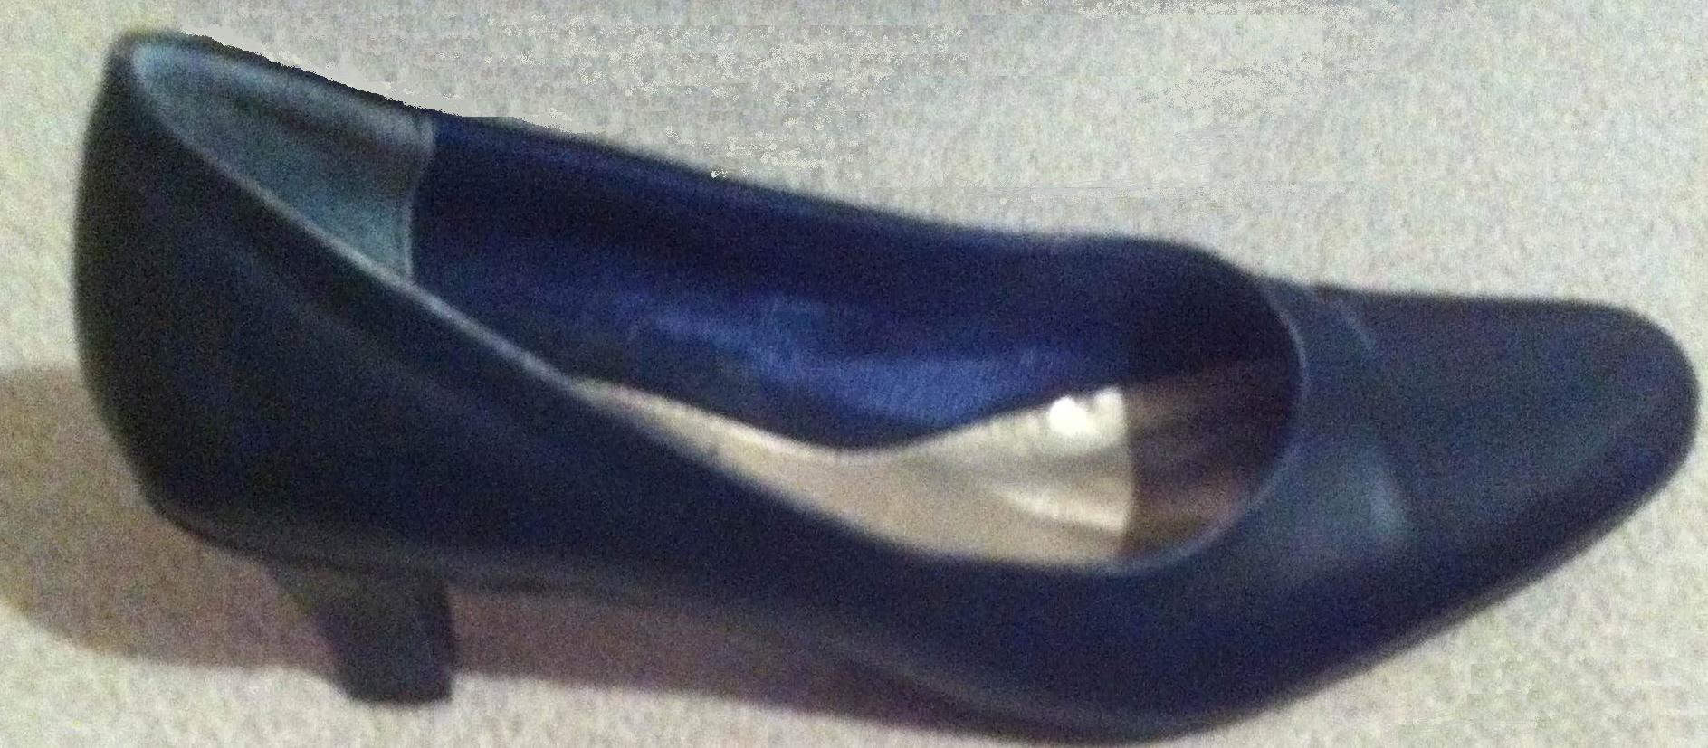

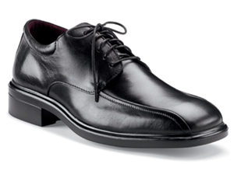
Men’s dress shoe in black or brown

Men’s dress belt; no more than 1” wide in black or brown
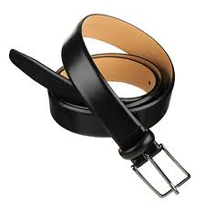

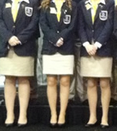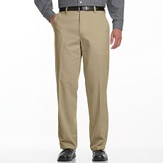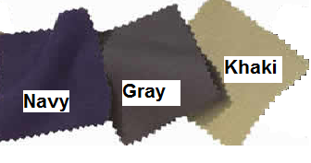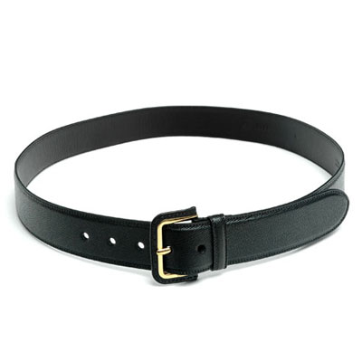
This style lady’s skirt which must be no more than 3” above the knee.
Lady’s dress belt; no studs or fancy decoration; no big buckle; no more than 1” wide; in black or brown
This style lady’s pants but can be pleated or flat front. It must have belt loops. No hip huggers, tight fitting, or frayed. Must be hemmed.
This style men’s pants but can be pleated or flat front. Must be hemmed.
We may pick one or more of these for you uniform colors. Try to match these colors.

